**Technical Test Backend Engineer**

Inventory API

1. Design a database for an oil and gas company that includes tables for users, products, and clients. The users table should have information for user ID, name, email, and password. The products table should have information for product ID, product name, description, and price. The clients table should have information for service ID, user ID, start date of collaboration, and contract value.

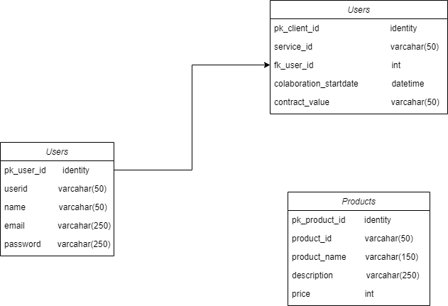

1. Create an API endpoint to get a list of all products available in the database. 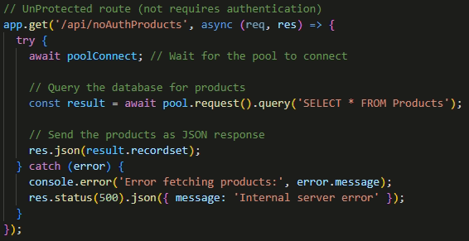
2. Create an integration test to test your API above

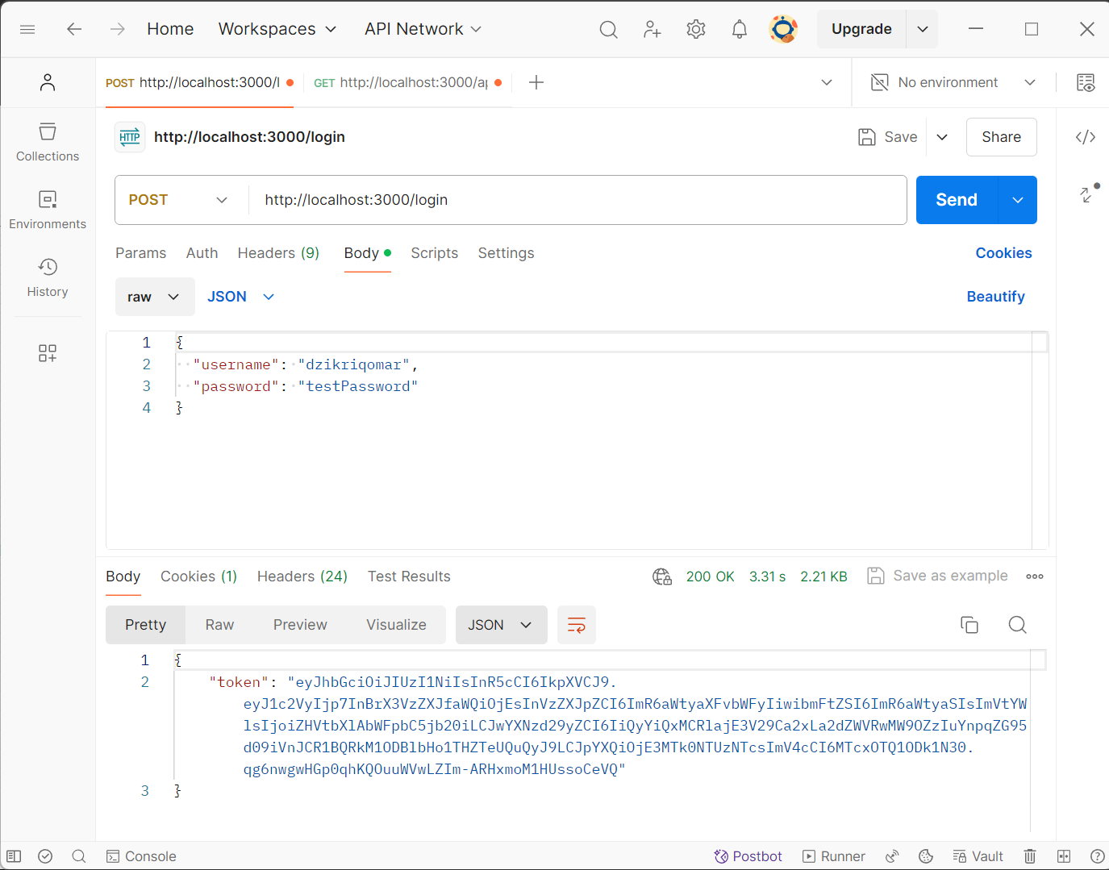

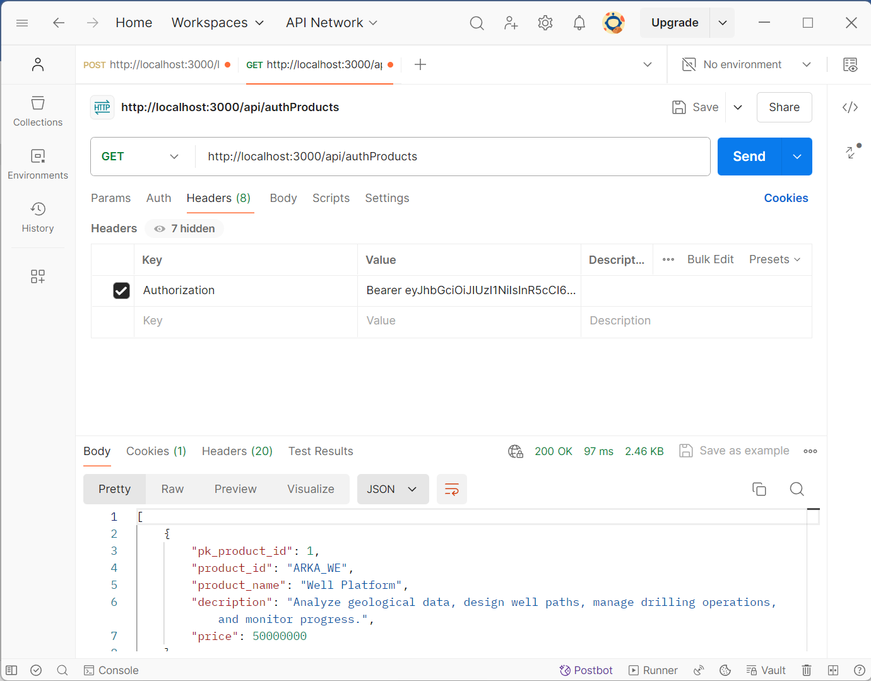

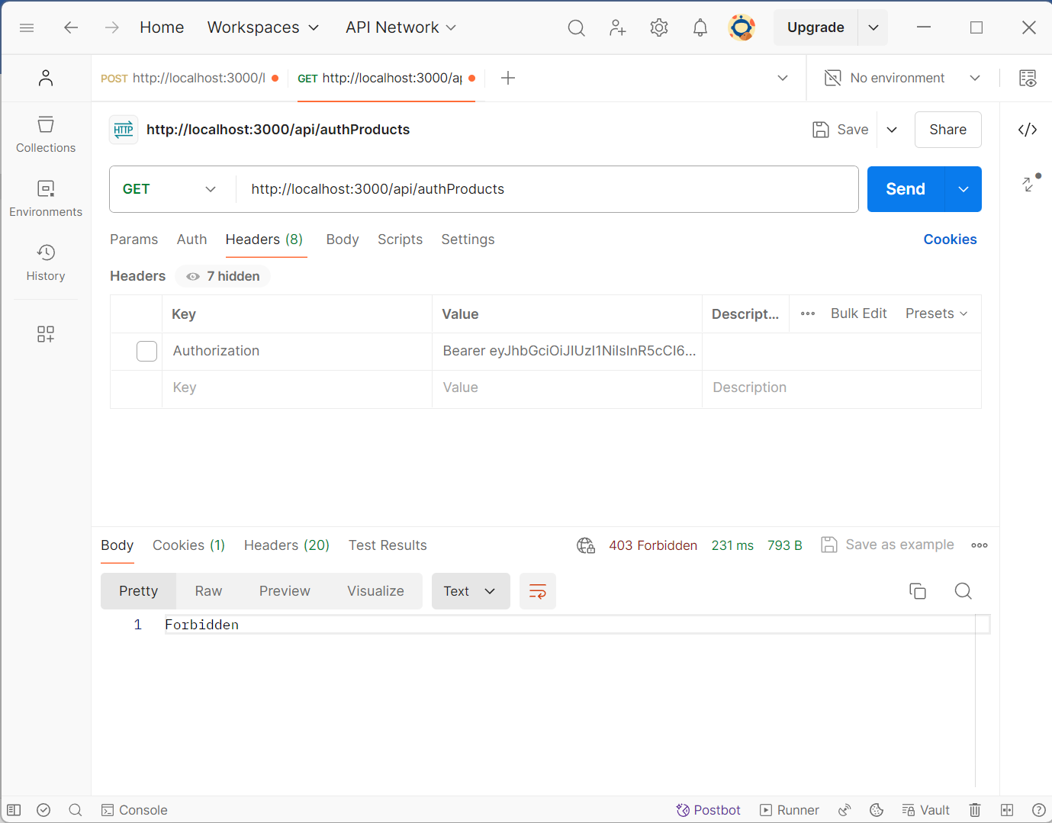

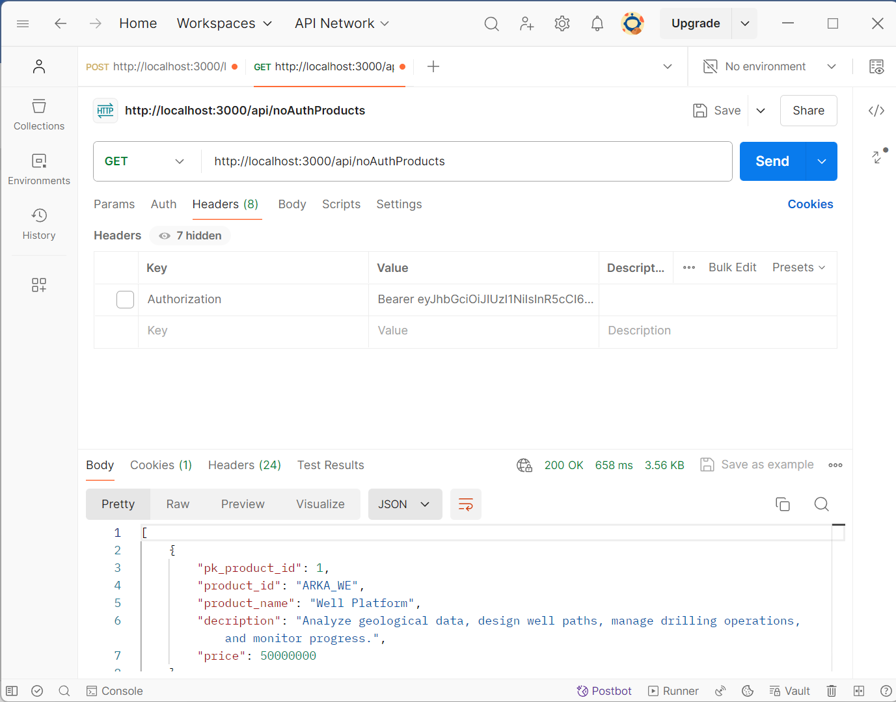

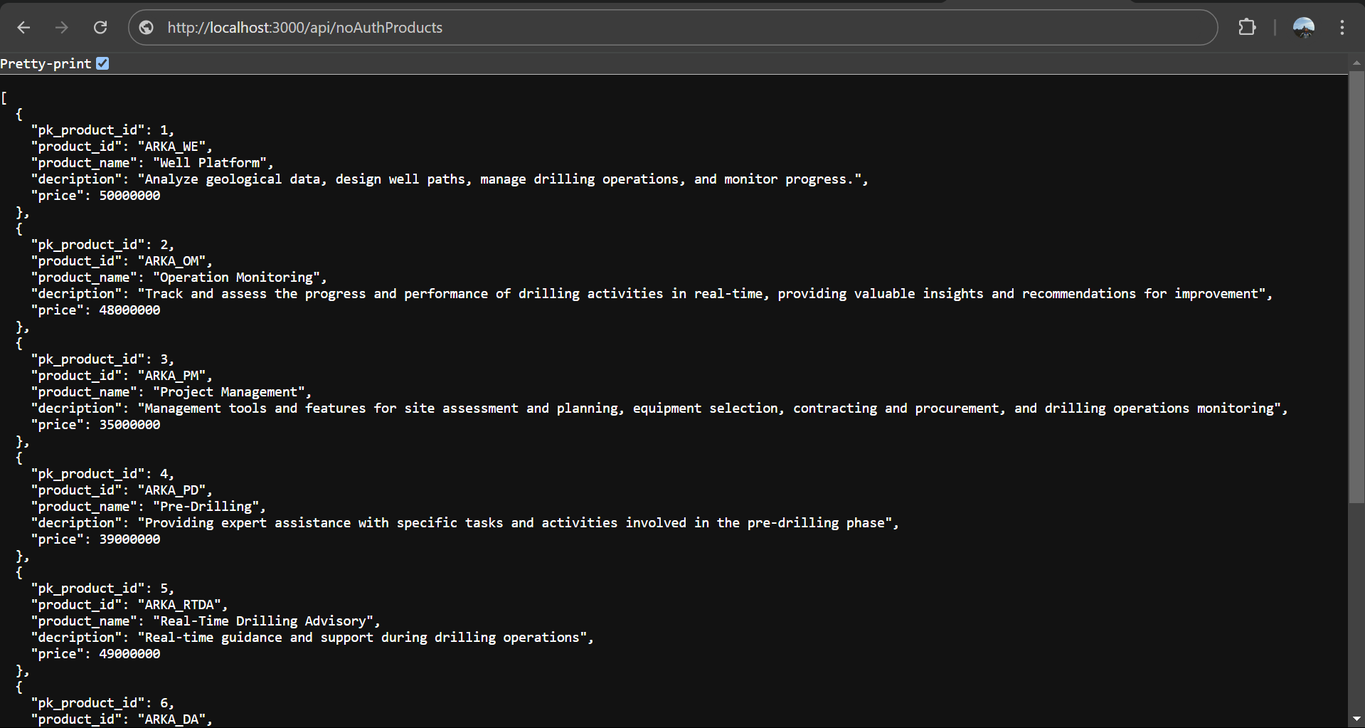

Python Function

1. Create a function in Python that removes duplicate elements from a list without changing the order of the elements.
2. Write an example unit test for your function above in Python using unittest.

Notes : ***Commit/upload the entire project to your GitHub account with the repository name: Take Home Test Arka. Include the URL link to the GitHub project repository (make sure the repository is accessible). Then send it via email with the subject: Take Home Test Arka - full name. (Ensure all answers to the tasks above are explained and provide complete instructions on how to run the program in the README file).***